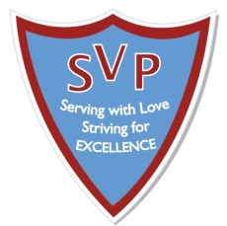
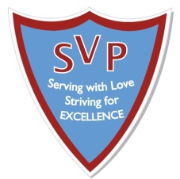
St Vincent de Paul
Catholic Primary School
Headteacher: Mrs L Salters
Assistant Headteachers: Mrs D. Foy and Mrs C. O’Keefe
Parish Priest: Rev, Fr, Ferdinand van Campen
Pitt Street Liverpool L1 5BY * Tel: 0151 709 2572 * Fax: 0151 707 8942
e-mail: vincent-ao@st-vincentdepaul.liverpool.sch.uk
_____________________________________________________________________________________________________
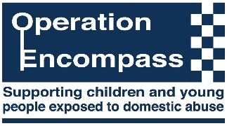
‘Serving with Love – Striving for Excellence’

Dear Parent / Carer

I am writing to inform you that our school participates in a Police led initiative called Operation Encompass. This is a partnership between schools and the Police that helps schools to better support any child where a domestic incident has been reported to Police from their home.

Following a domestic incident, the Police will make contact with the child’s school via secure email (usually the next day) and will communicate relevant information to a nominated, fully-trained member of school staff. This will ensure that as a school, we are made aware early enough, to support children and young people in a way that means they feel safe, supported and listened to. It will also provide an opportunity for school to offer support to the whole family.

Each school has members of staff called Key Adults who are trained to liaise with the Police, when required, whilst ensuring support is available to the child. Part of the school response may be to speak with the child to ensure appropriate support is offered.

The initiative was launched force-wide at the beginning of 2015. It is active in all Merseyside schools. You can find out more about Operation Encompass via the following site: www.operationencompass.org

If you would like to speak to someone further about the initiative, or require any additional information, please do not hesitate to contact Mrs Salters.

We are committed to working in partnership with local relevant organisations to keep children safe and to offer valuable support to all children across Merseyside.

Yours faithfully,

Mrs L Salters
Should you require any help or support regarding issues of domestic abuse, these are some local and national organisations:

- Women’s Aid and Refuge - freephone 24-hour National Domestic Violence Helpline 0808 2000 247
- Liverpool Early Help Directory www.ehd.liverpool.gov.uk includes information about agencies offering support with health, money and welfare rights, parenting, childcare, etc.
- Liverpool Domestic Abuse Services 0151 263 7474
- Merseyside Domestic Abuse Services 0151 709 8770
- RASA (Rape and Sexual Abuse Services) supporting current and historical sexual abuse 0151 558 1801
- Safe Place (Sexual Health Referral Centre) 0151 295 3550
- South Liverpool Domestic Abuse Services 0151 494 2222
- Savera UK 0800 107 0726 (working with Black Minority Ethnic communities regarding domestic abuse and harmful practices such as forced marriage, 'honour' based violence and female genital mutilation)
- WHISC (Women’s Health Information and Support Centre Liverpool) 0151 707 1826

